Ecoflame 2 Electric Fire Range

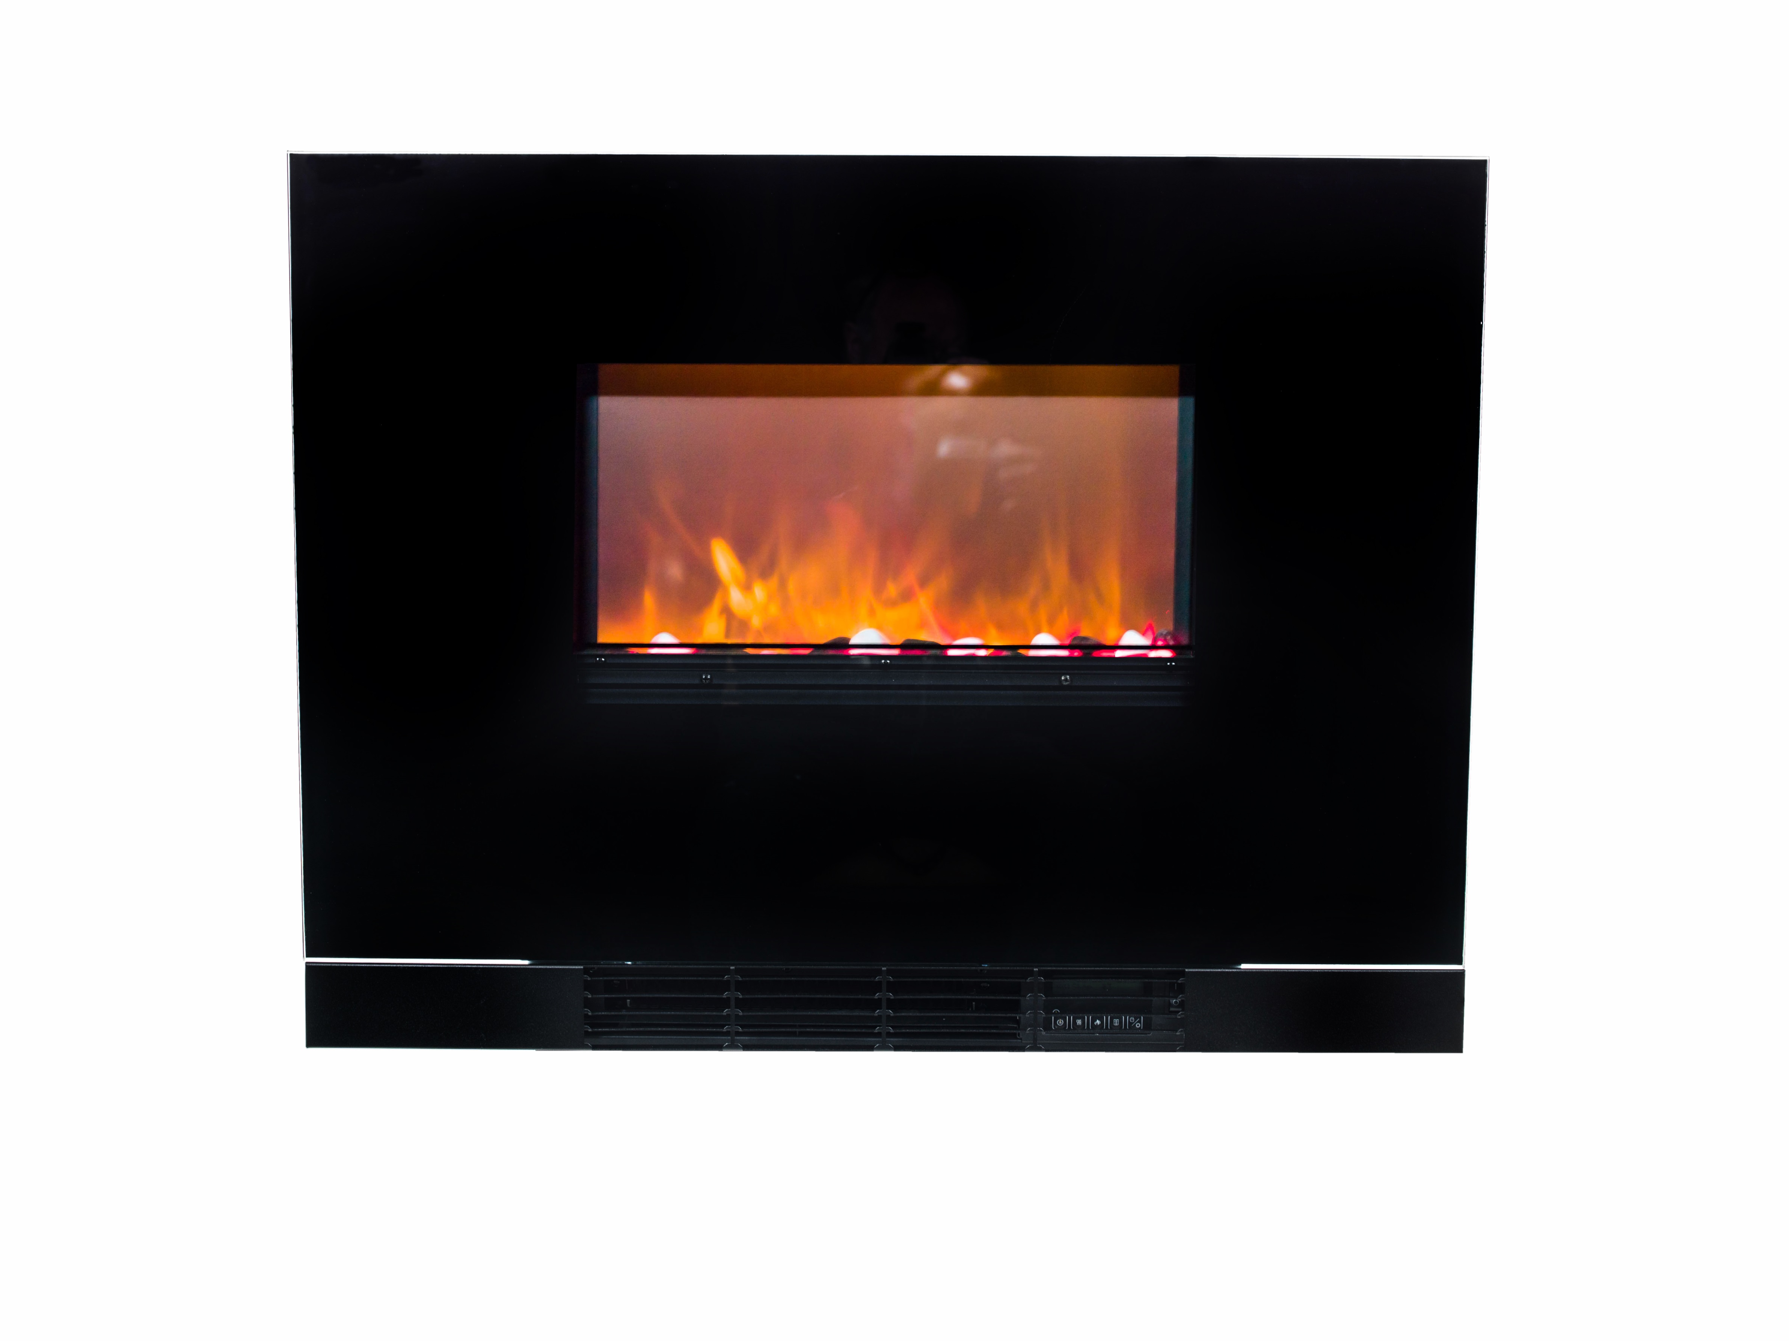

The Ecoflame 2 is a Landscape style, inset or wall mount fire featuring a realistic flame effect and Pebble fuel bed.
It is available with a Flat (illustrated) or Curved Black glass fascia (note Curved glass must be Partial inset fixing). It is supplied as standard 1.5KW output which, in addition to saving energy, makes it particularly suited to environments where pitches have limited power availability.
The heat outlet is at the bottom of the fire and blows outwards to allow low mounting to within 60mm of working sufaces. The heat outlet is also disguised by the drop down grill which allows access to the manual controls instead of the remote control handset.
The Ecoflame 2 is supplied as standard with thermostat control and remote control.
The product complies with the ECO Design Directive (EU) 2015/1188

SPECIFICATION
Overall height: | 619mm
Overall width: | 800mm
Overall depth: | 140mm (125mm inset Depth)
Weight: | 10Kg
Wall opening: (minimum) | 535mm High x 440mm Wide
Heat output: | 1.5 kW
Lead length | 2 metres
Remote control available (Y/N) | Y – Standard
ECO Directive Compliant (2015/1188) | Y
7 Day Timer | Y
Auto Open Window Detection | Y
Adaptive Start Control | Y

Widney Leisure Ltd
St Marys Road, Nuneaton, Warwickshire CV11 5AU UK
TEL: 02476 377550 FAX: 02476 388578

