Fuego ECO Electric Fire Range

FUEGO ECO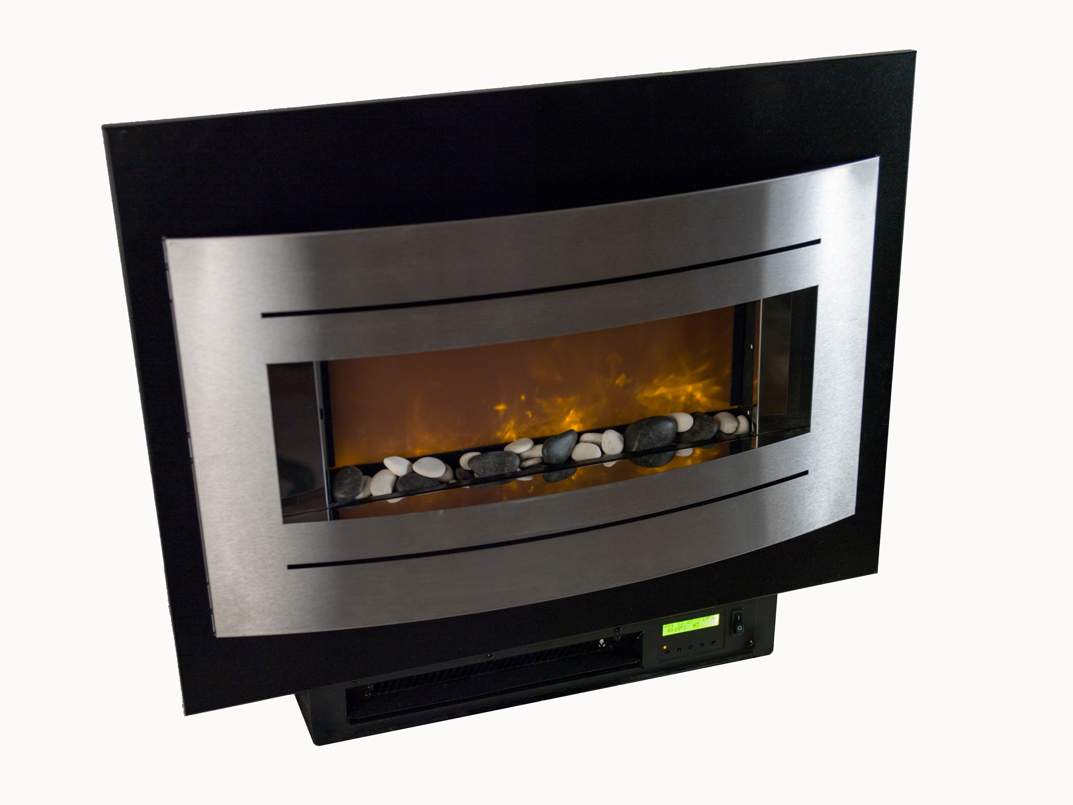

The Fuego ECO is a landscape style inset fire featuring a realistic flame effect and Pebble fuel bed.
It is supplied as standard 1.5KW output which, in addition to saving energy, makes it particularly suited to environments where pitches have limited power availability.
The Fuego ECO is supplied as standard with thermostat control and remote control.
The product complies with the ECO Design Directive (EU) 2015/1188

SPECIFICATION
Model | FL | FLQ Space Saver
Overall height: | 585mm
Overall width: | 720mm | 580mm
Overall depth: | 165mm
Weight: | 10Kg
Wall opening: (minimum) | 535mm High x 440mm Wide
Heat output: | 1.5Kw
Lead length | 2 metres
Remote control available (Y/N) | YES

Widney Leisure Ltd
St Marys Road, Nuneaton, Warwickshire CV11 5AU UK
TEL: 02476 377550 FAX: 02476 388578

